Report MB-JASS 2007

Tobias Knaf, Lehrstuhl für Biotechnologie, Universität Würzburg

Chronology of published investigations of
Corynebacterium glutamicum
in the department of biotechnology

Corynebacterium glutamicum is an important member of the class of actinobacteria. The investigation of this class is of high interest because members of this class like Mycobacterium tuberculosis, Mycobacterium leprae and Corynebacterium diphteriae cause dangerous diseases and infections. For the biotechnology the here presented Corynebacterium glutamicum is attractive not as a source of diseases but for the fermentation of amino acids. Every year 10⁶ tons of glutamate and 5.5 times 10⁵ tons of lysine are fermentated with the help of Corynebacterium glutamicum. While glutamate is acts like a flavour enhancer in food, lysine is used as an animal food supplement.
The corynebacteria are aerobic, non-sporulating and gram-positive. Figure 1 shows the typical form of the organism.

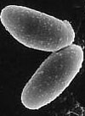
Figure 1: The gram-positive Corynebacterium glutamicum (found on www.genomenewsnetwork.org)

Like all mycolata Corynebacteria contain a thick peptidoglycan-layer which is covalently bound to arabinogalactan. To this arabinogalactan mycolic acids are linked by ester bonds. These mycolic acids act like a second permeability barrier similar to the outer membrane in gram-negative bacteria. For this reason channel-forming proteins (porins) are necessary to allow the passage of hydrophilic solutes through the cell wall. These porins are the main subject of investigations in the department of biotechnology, located in the biocenter of the university of Würzburg.
Such porins are also found in gram-negative bacteria where the outer membrane forms a 2nd permeability barrier. In the gram-positive bacteria except of the gram-positive mycolata the existence of porins couldn’t be revealed. So mycolata can be seen as a 3rd group of bacteria next to the gram-negative and the gram-positive bacteria (Figure 2).

Figure 2: The cell wall of mycolata with the porins embedded in the mycolic acids (Hünten et al)

The first investigations with Corynebacterium glutamicum in the department of biotechnology started with the breakage of the cells by French pressure followed by a sucrose-step gradient. Several different fractions could be collected but only one showed really high activity in reconstitution experiments with the black lipid bilayer. An additional NADH oxidase activity test demonstrated that the highly-active fraction was free of cytoplasmic membrane. The pore-forming polypeptide was purified using fast protein liquid chromatography (FPLC). Therefore the proteins were first of all precipitated by stirring for 10 h in one part chloroform and two parts methanol. After centrifugation, the cells in the supernatant were mixed with ether in a dilution of one to nine and kept overnight at minus 20 degrees. The protein was dissolved on the next day in 0.4 % LDAO and 10 mM Tris-HCl (pH 8) and subjected to FPLC across a Mono Q column. The following 10 %-tricine containing SDS-PAGE showed a pure 5kDa polypeptide when stained with silver. This pure 5kDa protein of the cell wall of Corynebacterium glutamicum named PorA formed defined channels of 5.5 nS in 1M KCl (Figure 3a). The increase of conductance could be observed up to 30 minutes and up to 10⁶ channels per cm². The histogram of more than 100 formed channels in the membrane showed also a second, minor fraction of half conductance which could be explained by substates or part of oligomers (Figure 3b).

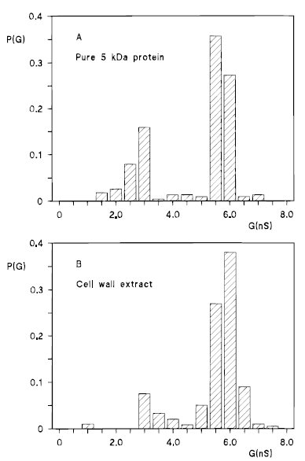
B
A

Figure 3a und 3b: Diagram of single-channel conductance measurements and histogram of more than 100 channels
formed in the membrane (Lichtinger et al)

For estimating the ion-selectivity of the channels, the average single-channel conductance G of the cell wall channel was tested using different salt-solutions. The channels showed cation-selectivity because the exchange of the cations by less mobile cations showed higher decrease of the conductance than the exchange of the anions by less mobile anions. The exchange of potassium in potassium-chloride by lithium decreased the conductance from 5.5 nS for KCl to 2.6 nS for LiCl. The exchange of chloride in potassium-chloride by acetate decreased the conductance G only to 4.8 nS for KCH₃COO⁻.
By using the Renkin factor and the data of the dependency of the conductance to different salt solutions, the diameter of the cell wall channel could be calculated with an average value of 2.2 nm. No linearity could be found between the conductance G and the salt concentration. Additionally there wasn’t any saturation observed which indicates that the cation-selectivity shouldn’t be related to any binding site. This non-linearity shows with a slope of 0.5 on a double-logarithmic scale the influence of point net charges near or in the channel mouth. The best fit between conductance and salt concentration was found for 2 negative point net charge with a total charge of q = -3.2*10⁻¹⁹.
For the measurement of the zero-current membrane potential V_{m} a 10-fold salt-gradient was established by adding a salt-solution to only one side of the membrane. In every case the more diluted site became positive which indicates a movement of cations over the membrane. The zero-current membrane potential was about + 31 mV for lithium chloride and up to + 43 mV for potassium acetate. This result of positive zero-current membrane potentials is in agreement with the observed cation-selectivity of the channel formed by the 5 kDa-protein. This selectivity could also be affirmed by calculation of the permeability ratio of cations to anions using the Goldman-Hodgin-Katz equation. The permeability ratio of cations to anions was always much higher than 1 which means that cations have higher permeability through the channel than anions.

For the next publication, done by Lichtinger et al. in the year 2001, the localization of PorA was prooved. By treatment with anti-PorA IgG PorA could be localized in the cell envelope with fluorescence imaging. Same results were revealed with electron micrograph imaging. PorA was visualized in the cell envelope after treatment with anti-PorA IgS and anti-rabbit IgG labelled with gold particles (Figure 4).

Figure 4: Electron micrograph image of Corynebacterium glutamicum cells, treated with anti-PorA IgS and anti-rabbit IgG labelled with gold particles (Lichtinger et al., 2001)

The sequencing without CNBr-cleavage wasn’t successful. After CNBr-cleavage a 43 amino acids long polypeptide could be determined. PCR using the primers from the amino acid sequence of PorA wasn’t completely sufficient to reconstruct the whole nucleotide sequence with the flanking regions in 3’ and 5’ directions. Therefore inverse PCR was used to evaluate the whole porA gene and its flanking regions. Only with using the restriction enyme Bgl II a PCR product of 1.4 kb was observed. The 1.4 kb gene-fragment was cleaved into puc18 and 3 positive clones were revealed. None of the three contained the full 1.4kb gene fragment but after sequencing and with the known DNA sequence of parts of the porA gene from direct PCR, it was possible to reconstruct the whole nucleotide sequence and its flanking regions. The nucleotide sequence shows an open reading frame ORF of 138 bp, encoding a protein of 45 amino acids. No N-terminal amino acid extension was detected which suggests that a different export system next to the known Sec-system was used for the export to the cell wall.
In following southern blot analysis hybridization of the porA gene with chromosomal DNA from different mycolata was investigated. Under high stringency conditions of 60°C, there was only one hybridization signal detected for Corynebacterium glutamicum while under medium stringency conditions only two to three bands were observed which shows that Corynebacterium glutamicum might contain more than one gene for the cell wall channels. Under low stringency conditions of 48°C bands for all corynebacteria were detected indicating conserved sequences for porins in the chromosome. No hybridization was observed for Rhodococcus erythropolis and Nocardia corynebacteroides. There seem to be no homologous DNA sequences to porA.
The next investigations were done by Noelia Costa-Riu. She deleted the porA gene and observed the resulted ΔporA mutant of Corynebacterium glutamicum. The deleted fragment had a size of about 150 bp. With the porA gene 30 bp before the start codon and 13 bp after the stop codon were deleted but no open reading frame ORF was touched by the deletion (Figure 5). As a conclusion, only the deletion of porA was responsible for the observed phenotype.
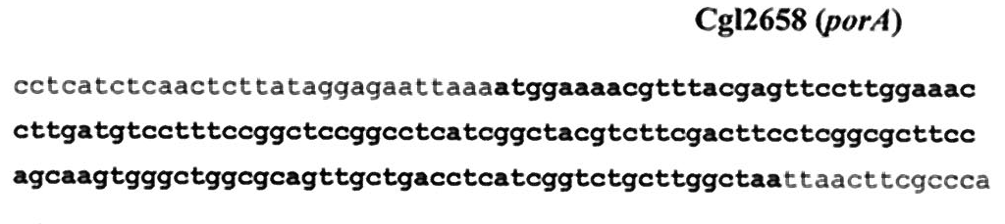

Figure 5: deletion of porA withing the genome of Corynebacterium glutamicum without touching any ORF

RT-PCR of total mRNA from wild-type Corynebacterium glutamicum and the ΔporA mutant strain showed only one amplification signal with porA-specific primers Por1 and Por2 in the wild-type but none in the mutant strain. So, only one gene is coding for PorA in the C. glutamicum chromosome.
For estimating the influence of PorA on antibiotical susceptibility, the diameter of the inhibition zones of growth were measured with the disc-method using different antiobiotics. With all the antibiotics, there was an increase of antibiotical resistance in the ΔporA mutant strain. Furthermore, for Ampicillin and Tetracycline a total resistance of the mutant strain could be observed. As a result of the antibiotic test, PorA seems to play a major role of PorA in transport mechanisms of antibiotics. This major role might be caused by the large diameter of the channel and its preference for positively charged solutes.
Growth curves in different media were measured for wild-type and ΔporA mutant strain of Corynebacterium glutamicum. In the rich medium at 30°C there were no differences of growth characteristics between the strains in the exponential phase. Only in the late logarithmic phase and in the stationary phase a decreased growth of the mutant strain compared to the wild-type strain could be observed. It can be explained with diffusion effects which are sufficient to support growth at high nutrient concentrations and low cell densities in the beginning of the culture. When the nutrient concentrations decrease and the cell densities increase, diffusion isn’t sufficient for growth anymore and the growth rate decreases compared to the wild-type strain. In minimal medium at 30°C a decreased growth of the mutant strain could be observed all the time caused by a decreased nutrient influx. But in both media, there was always growth of the ΔporA mutant strains. A different channel must exist, otherwise the deletion of PorA should be lethal for the organism. Other experiments showed that the existence or non-existence of PorA has no influence on the glutamate production, indicating that there are no (permeability-) differences for the export of the negative charged glutamate.
Single-channel recordings in the presence of ΔporA mutant cells showed channels with a very low conductivity of 0.7 nS in 1 M KCl. This small channel was anion-selective and explains why the deletion of PorA was not lethal for Corynebacterium glutamicum. Single-channel recordings in the presence of a synthetic PorA revealed the same channel as in the wild-type indicating that PorA alone is responsible for the 5.5 nS channel in 1 M KCl.
For further investigations with the ΔporA mutant strain the influence of different carbon sources to the growth parameters were tested. The wild-type cells and the ΔporA mutant cells were grown on glucose, maltose, sucrose, ribose, pyruvate, lactate and finally citrate and the doubling time in hours and the final optical densitiy in 660 nm were measured. With neutral or negatively charged carbon sources no change of growth was observed between wild-type and mutant cells. Only citrate pointed out differences. The final optical density decreased with factor 5 and the doubling time was more than doubled (Table 1).

Table 1: Growth parameters of wild-type and ΔporA mutant cells of C. glutamicum on different carbon sources (Costa-Riu et al., 2003)

But as seen in table 1 the ΔporA mutant strain still grew in every case. So, the mutant strain must have still certain permeabilities and other channels have to exist in the cell wall. These results are in agreement with other experiments when the strains were grown on minimal media with glucose on the one hand and citrate on the other hand.
The polypeptide which forms channel with a small conductivity of 0.7 nS in 1 M KCl was named PorB. The polypeptide was first extracted and precipitated in organic solvents (chloroform and methanol). After centrifugation the supernatant was diluted with ether and kept overnight in the cold. The protein was dissolved in 0.4 % LDAO and 10 mM Tris-HCl (pH 8) and subjected to fast protein liquid chromatography (FPLC). Different fractions were collected from the FPLC and in one fraction the pure highly-active 10 kDa-protein PorB was visualized with a 10 % tricine containing SDS – PAGE (polyacrylamid gelelectrophoresis). By using different salt solutions a higher influence of anions on the single-channel conductance G was found pointing out an anion-selectivity (Figure 6).

Figure 6: Average single-channel conductance G of PorB in different salt solutions (Costa-Riu et al., 2003)

This result is in agreement with zero-current membrane potential measurement when adding a 10-fold salt gradient. Zero-current membrane potentials between -28 mV (LiCl) and -30 mV (KCl) were measured, indicating a certain anion-selectivity with a pass of anions through the membrane. Also the permeability ratio P_{cation} to P_{anion} was about 0.13 which means that anions have a higher permeability than the cations.
Partial sequencing using Edman degradation and an additional blast revealed the 126 amino acids long porB_{C.glut.}-gene and a second, PorB-like protein named PorC_{C.glut.}. porB_{C.glut.}and porC_{C.glut.} contain in contrast to porA_{C.glut.} a N-terminal extension. With the existence of this N-terminal extension as a targeting signal both seem to use the Sec-apparatus as an export system. Between both genes no transcription terminator was found. Both genes could be cotranscribed respectively building a cotranscriptional unit. This suggestion could be affirmed by using reverse transcription with porB-specific primers, porC-specific primers and porB-porC-specific primers. With each primer a band occurred showing that porB_{C.glut.}and porC_{C.glut.} form a cotranscriptional unit.

In the year 2005 Hünten et al. published data about a new channel-forming protein named PorH, which is present in the cell wall of Corynebacterium efficiens and Corynebacterium callunae. Both bacteria strains are close relatives to Corynebacterium glutamicum.
After precipitation with organic solvents and purification with FPLC a pure 6 kDa protein, named PorH, was found in both strains. PorH_{C.call.} formed channels with an average single-channel conductance G of 3 nS in 1 M KCl. An additional voltage-dependent closure was observed for voltages higher than 30 to 40 mV. PorH_{C.eff.} formed defined channels of 2.3 nS respectively 4.7 nS in 1 M KCl. The second, higher conductance could be caused by the reconstitution of two channels at once. In average single-channel conductance measurements with different salt solutions no linearity between conductance and salt concentration was found pointing out the existence of point net charges near or in the channel mouth. PorH_{C.call.} was highly cation-selective. This selectivity could be affirmed by zero-current membrane potentials measurements when the potential was about + 28 mV. The permeability ratio P_{cations}/P_{anions} was about 7 which means that the cations have a much higher permeability than the anions. In contrast to PorH_{C.call.}, PorH_{C.eff.} was slightly anion-selective. The zero-current membrane potential was – 6 mV and the permeability of cations to anions was 0.7.
After partial sequencing using Edman degradation and after blasting the porH gene loci of C. efficiens, C. callunae and C. glutamicum were compared. For porH_{C.eff.} 174 bp are encoding a 57 amino acid long polypeptide which is acidic (6 negative charges, 2 positive charges). No leader sequence was found which means that the Sec-System couldn’t be used for the export. PorH_{C.call.} was highly homologous to porH_{C.eff.} and also acidic with 8 negative and 2 positive charges. So the charges by themselves can’t be the cause for the different ion-selectivities of PorH in both strains. The different ion-selectivity might be caused by the different arrangement of the amino acids in the channel forming unit.
PorA and porH of Corynebacterium callunae were only separated by 77 bp. No transcription terminator was found between them which points out that porA and porH could form a cotranscriptional unit.
Single-channel conductance of PorH_{C.call.} as a function of the KCl concentration showed neither linearity nor saturation. No binding site seems to exist but point charges might be located near or in the channel mouth. The best fit was found for a channel diameter of 2.2 nm and 1.6 negative charges with a total charge q of - 2.4* 10⁻¹⁹ As. PorA_{C.glut.} was controlled by 2 negative charges with a total charge q of – 3.2*10⁻¹⁹ As.
Schematic prediction of the secondary structure of PorH revealed that heptamers of amphipathic α–helices with about 8 windings and a length of 4.2 nm are sufficient to span the mycolic acid layer of corynebacteria (Figure 7).
mycolic acids
a,d,e = hydrophobic residues
b,c,f,g= hydrophilic residues
= negative charge
= positive charge

Figure 7: Schematic prediction of the secondary structures of PorH_{C.eff.} (anion-selective) and PorH_{C.call.} (cation-
selective), Hünten et al 2005
The hydrophobic residues a, d and e are arranged to the mycolic acids, while the hydrophilic residues b, c, f and g are facing the lumen. The arrangement of the charges in the channel-forming unit is in agreement with the different ion-selectivities. While PorH of Corynebacterium efficiens isn’t charged respectively neutral charged, PorH of Corynebacterium callunae has an excess of two negative charges pointing out the cation-selectivity.
As Corynebacterium efficiens and Corynebacterium callunae are close relatives to Corynebacterium glutamicum, the cell wall of Corynebacterium glutamicum was checked for the channel-forming protein PorH_{C.glut.}. The cells were broken with French pressure and the polypeptide was precipitated using organic solvents like methanol and chloroform. Finally the precipitated protein was purified with fast protein liquid chromatography FPLC and a pure 12 kDa-protein was found. The 12 kDa-protein, named PorH_{C.glut.}, formed defined channels with an average single-channel conductance G of 2.5 nS in 1 M KCl. Also a second, minor fraction with a lower conductance of the half size of the main channel was observed in the histograms of more than 100 formed channels in the membrane. The two different fractions might be monomers and dimers or other substates of a channel.
Average single-channel conductance measurements with PorH_{C.glut.} in different salt solutions revealed a higher cation influence. This cation-selectitvity was assured by the zero-current membrane potential of + 25 mV and a permeability ratio of cations to anions of 5.1 which was calculated using the Goldman-Hodgin-Katz equation. No linearity between conductance and salt concentration was found so that point net charges seem to be involved.
Partial sequencing showed for porH_{C.glut.} that 174 bp are encoding a 57 amino acids long hypothetical protein. The sequence of porH_{C.glut.} was highly homologous to the sequence of porH_{C.eff.}. The total mass of the protein was about 6.1 kDa. As the gel after purification showed a band of about 12 kDa, this band must be the result of the formation of dimers. The really big excess of negative charged amino acids in the sequence of porH_{C.glut.} is in total agreement with the found cation-selectivity.
An overview of the porH_{C.glut.} gene locus demonstrated that porA and porH are only separated by 83 bp without any transcription terminator between them. A RT-PCR with the use of 13 primers showed amplification signals for all the primers which suggests that porA and porH art part of a transcriptional unit of 13 genes.
Finally, western-blot analysis of PorH_{C.glut.} using anti-PorH_{C.glut.} antibodies were done to detect the existence of oligomers. After extraction with LDAO the formation of oligomers, mainly in form of hexamers, was detected even after boiling for 5 minutes. In contrast, the oligomers were destroyed when precipitated with urea or organic solvents. Only mono- or dimers were found.
The last experiments done were the electron micrograph analysis of Corynebacterium glutamicum cells after treatment with several antibodies. For every channel-forming protein was used a specific antibody. The images showed signals in the cell envelope for the use with anti-PorA_{C.glut.}, with anti-PorB_{C.glut.}, with anti-PorC_{C.glut.} and anti-PorH_{C.glut.} (Figure 8). Additionally, for every antibody occurred a band on a gel. So it can be said, that all channel-forming proteins are present in the channel at the same time. There is a coexistence of PorA, PorB, PorC and PorH in the cell envelope of Corynebacterium glutamicum.

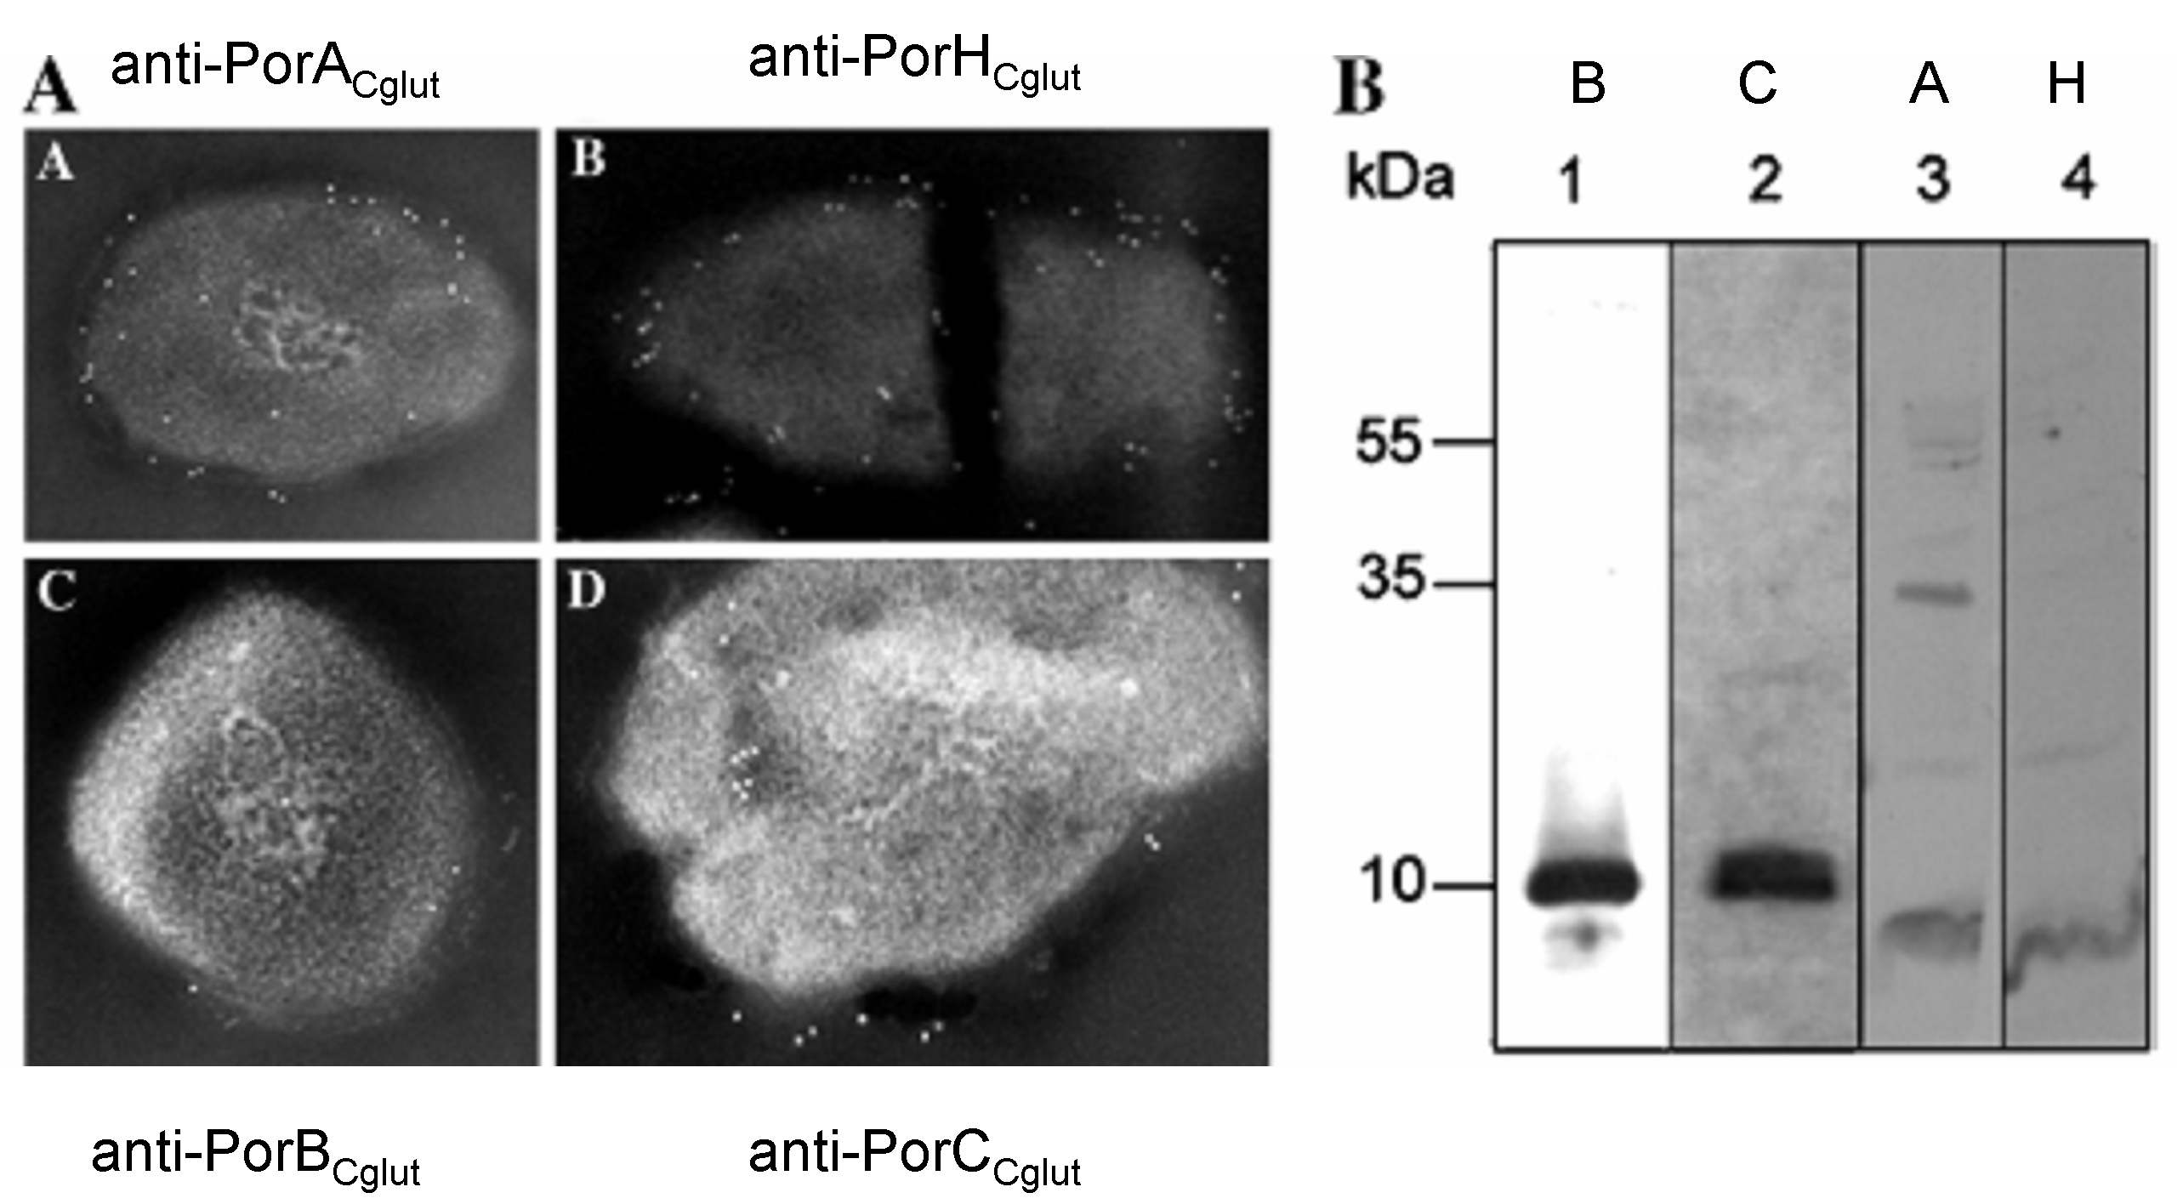

Figure 8: Coexistence of all 4 channel-forming proteins in Corynebacterium glutamicum (Hünten et al, 2005)

As a summary of all results we can say that all four channel-forming proteins PorA, PorB, PorC and PorH coexist in the cell envelope of Corynebacterium glutamicum. Por A is a 45 amino acids long polypeptide which forms cation-selective channels with a single-channel conductance of 5.5 nS in 1 M KCl. PorB is a 99 amino acids long polypeptide which forms small anion-selective channels with a single-channel conductance of about 700 pS in 1 M KCl. The channel formed by PorB can be blocked by citrate. PorC is a PorB-like protein and their genes porB and porC belong to the same cluster so that both are cotranscribed. Finally, PorH is a 57 amino acids long polypeptide which forms cation-selective channels with a single-channel conductance of 2.5 nS in 1 M KCl. porH is located next to porA and both form together a cotranscriptional unit.
References:

1) Niederweis, M., E. Maier, T. Lichtinger, R. Benz, and R. Krämer. 1995.
Identification of channel-forming activity in the cell wall of Corynebacterium
glutamicum. J. Bacteriol. 177:5716–5718.
2) Lichtinger, T., Burkovski, A., Niederweis, M., Krämer, R. & Benz, R. (1998). Biochemical and biophysical characterization of the cell wall channel of Corynebacterium glutamicum: the channel is formed by a low molecular mass subunit. Biochemistry 37, 15024–15032.
3) Lichtinger, T., F. G. Rieß, A. Burkovski, F. Engelbrecht, D. Hesse, H. D. Kratzin, R. Krämer, and R. Benz. 2001. The low-molecular-mass subunit of the cell wall channel of the Gram-positive Corynebacterium glutamicum. Immunological localization, cloning and sequencing of its gene porA. Eur. J. Biochem. 268:462–469.
4) Costa-Riu, N., Burkovski, A., Krämer, R. & Benz, R. (2003a). PorA represents the major cell wall channel of the gram-positive bacterium Corynebacterium glutamicum. J Bacteriol 185, 4779–4786.
5) Costa-Riu, N., Maier, E., Burkovski, A., Krämer, R., Lottspeich, F. & Benz, R. (2003b). Identification of an anion-specific channel in the cell wall of the gram-positive bacterium Corynebacterium glutamicum. Mol Microbiol 50, 1295–1308.
6) Hünten, P., Schiffler, B., Lottspeich, F. & Benz, R. (2005). PorH, a new channel-forming protein present in the cell wall of Corynebacterium efficiens and
Corynebacterium callunae. Microbiology, 151, 2429 – 2438
7) Hünten, P., Costa-Riu, N., Palm, D., Lottspeich, F. & Benz, R. (2005).
Identification and characterization of PorH, a new cell wall channel of Corynebacterium glutamicum. Biochimica et Biophysica Acta 1715 (2005) 25 – 36

